General Observations.

The following three points will be some of the observations we have seen in the data and here they are:
- This boxplot shows us that The drugs Capomulin and Ramicane seem to be associated with a lower median final tumor volume and at the same time their interquartile ranges are also smaller and more compact. This could suggest that they are more effective in reducing the size of the tumors, on the other hand close interquartile ranges suggests that the treatment results are more consistent among different subjects for these drugs compared to Infubinol and Ceftamin.
The outlier we see in the Infubinol team needs further investigation to what coused to be such different
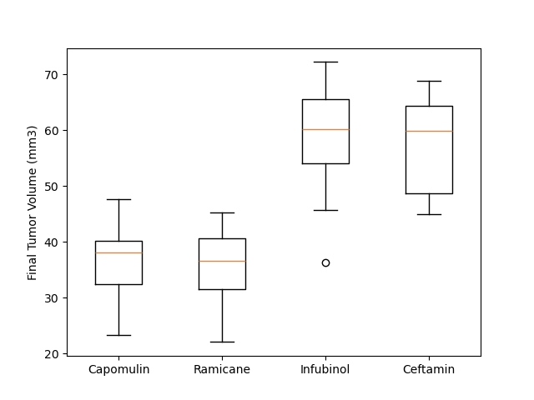Figure 1: Boxplot

- The image you've uploaded is a scatter plot, which is used to observe the relationship between two quantitative variables. In this case, the scatter plot is displaying the relationship between 'Weight (g)' on the x-axis and 'Average Tumor Volume (mm^3)' on the y-axis. Here's an what we observed in the picture below:
  - Correlation: There appears to be a positive correlation between the weight of the subjects and the average tumor volume. As the weight increases, the average tumor volume also tends to increase. The correlation seems to be moderate to strong, as the points show a clear upward trend as they move from left to right, though they are not tightly clustered along a line.
  - Causation vs. Correlation: While there is a visual correlation, the scatter plot does not provide evidence of causation. Additional analysis would be required to determine whether the weight has a direct effect on the tumor volume, or if both variables are influenced by another factor.
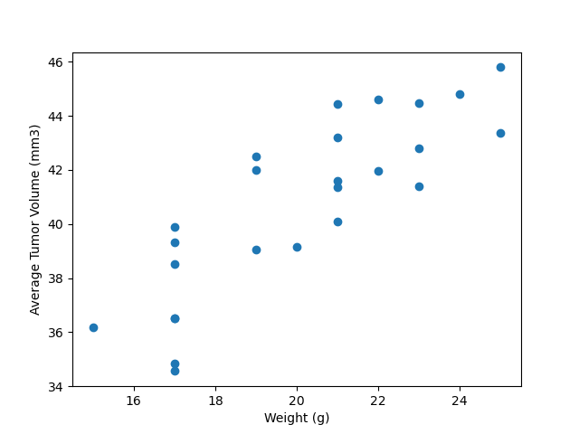
Figure 2: Scatter plot
- The image you've provided is a scatter plot with a red line of best fit, indicating the relationship between mouse weight and average tumor volume for mice undergoing the Capomulin treatment regimen. Here are the observations:
  - As the first figure show , it appears to be a positive correlation between mouse weight and average tumor volume. As the weight of the mouse increases, the average tumor volume also increases. The red line which we see in the figure 3 represents and strengthens the theory of positive correlation. the line of best fit through the data points and suggests the general trend of the relationship. The slope of the line indicates the direction and rate of change in tumor volume with respect to mouse weight.
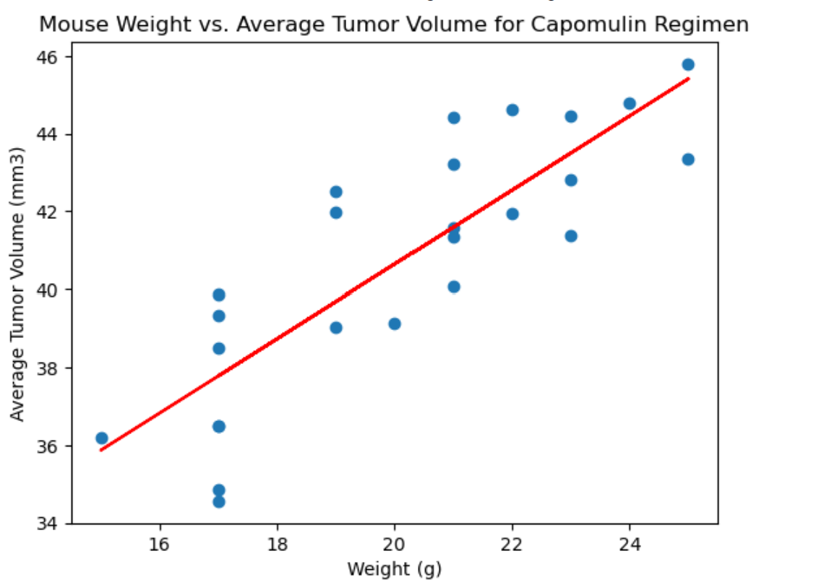
Figure 3: Correlation Coefficient and a Linear Regression model

Conclusion:
The combined details of the 3 figures we represented above suggests that while Capomulin is effective in reducing tumor size, there is also another trend where the factor of mouse weight correlates with the average tumor volume. This could imply that weight plays a role in the treatment's effectiveness, or possibly that larger mice inherently develop larger tumors.

